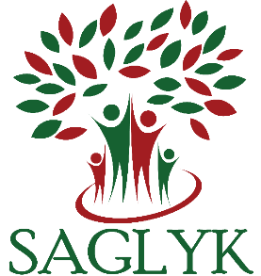

TURKMEN INNOVATION LAB

APPLICATION FORM

Dear Friend!
Are you looking for an opportunity to make a positive change in Turkmen people’s lives? Do you have this great idea but haven’t implemented it because you do not have time and resources, and you cannot find like-minded people who can help you?
We are inviting you to pitch your idea, plan, build a team and get funding to implement your innovative project. Tell us about yourself and share your project idea and thoughts on how it can benefit the people of Turkmenistan.
You can apply as an individual or as a group, and we welcome group projects from both registered organizations and informal groups.
The Innovation Lab aims to raise awareness of people like you: bloggers, citizen journalists, and youth activists from Turkmenistan about the values of social media and information and communication technology (ICT) in societal development (education, health, business, and agriculture) and connect individuals with innovative ideas. The goal of the lab is to help Turkmens build their practical skills, professional networks, and to improve access to information via technologies available in Turkmenistan.
The deadline for applications is August 15, 2017. The workshop will take place in Tbilisi, Georgia on November 15-17, 2017. Selected participants are expected to attend the full 3-day intensive workshop. The workshop will provide participants with the opportunity to develop the project ideas further and pitch them for funding. The funding decision, which will be made after the workshop, will support successful projects. All costs relating to participation in the workshop will be covered by the organizer.
If you have any questions please contact us at saglykda@gmail.com

PLEASE SHARE YOUR THOUGHTS AND

PLANS IN THIS APPLICATION FORM

Your name: _____________________________________________________________________________
Email: _________________________________________________________________________________
How do you position yourself? Please check as many as applicable: Blogger? Journalist? Activist? Coder? Website builder? Programmer? Expert in ____________________________________________

Are you applying as an Individual? Group? Organization?
In one page, let us know about your proposed project with the following in mind:
- What is your idea? What do you propose to do?
- Tell us about the format of your project, such as mobile app, video/documentary, videogame, audio, still photography, multimedia, etc.
- Give us a more detailed description about what your project does, how it will work, how it will improve the lives of Turkmen people. Why will your approach succeed?

